**Superior University Reiwend Road**

Name: Haseeb Arshad

Roll no: SU92–BSSEM-F22-177

Section:5D

Subject: CN Lab  
Task 2

Submitted to: Sir Rasikh Ali

**Task 1:**

**Implement VLAN and Inter-VLAN Routing in Cisco Packet Tracer, in the network topology of LAB-7 and LAB-8**

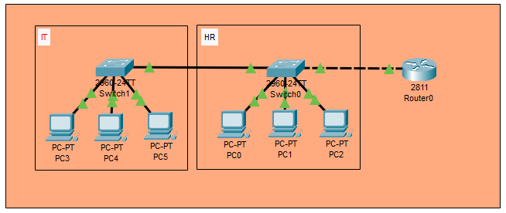

**Configure Switch:**

